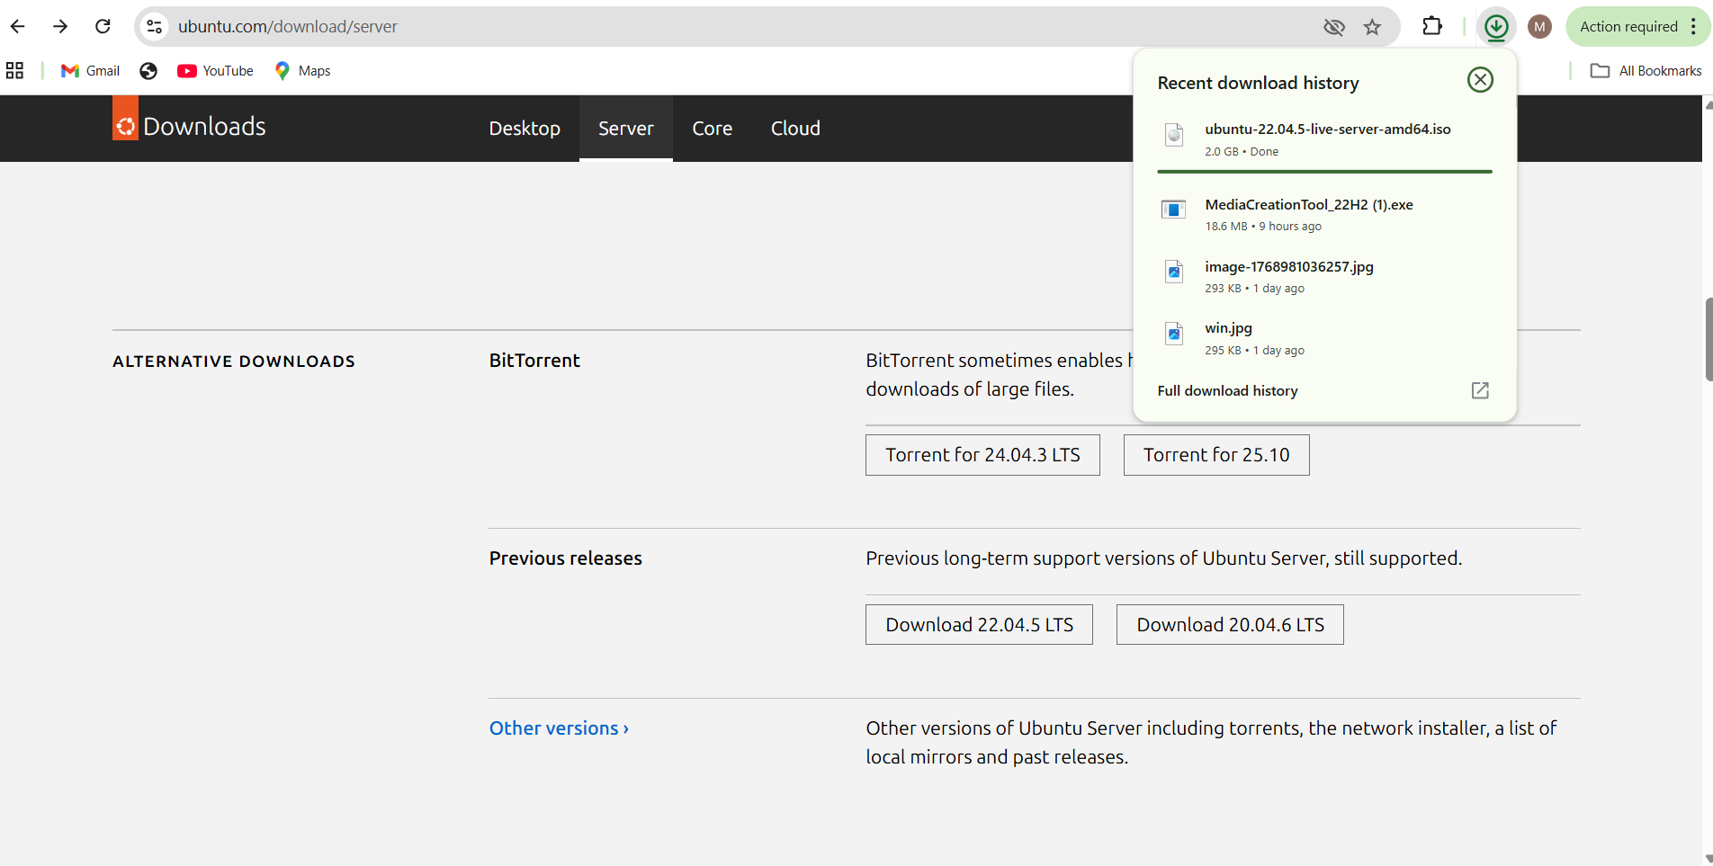
- Step 1: Download Ubuntu Server ISO
- Open a web browser.
- Go to: https://ubuntu.com/download/server
- Download Ubuntu Server 22.04 LTS.
- The downloaded file name will be similar to:
ubuntu-22.04.x-live-server-amd64.iso
- Save the ISO file in a known folder on your system.
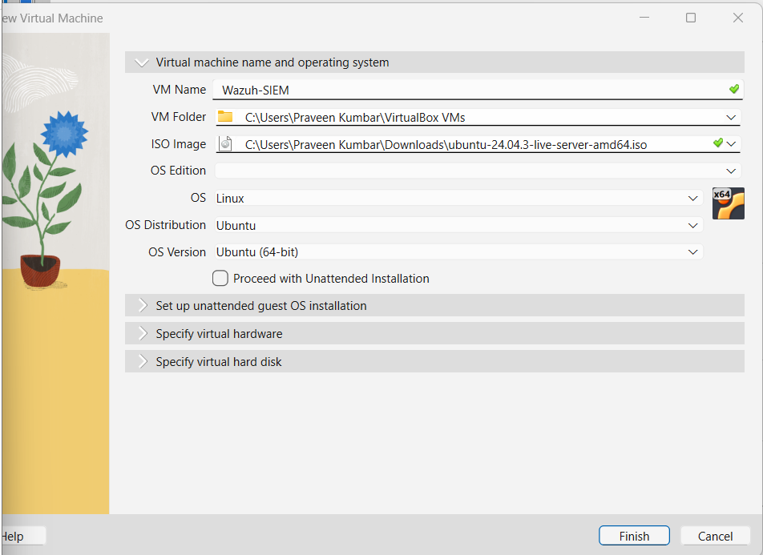

Step 2: Create a New Virtual Machine
- Open Oracle VirtualBox.
- Click New.
- Enter the following details:
- Name: Ubuntu-Server-Wazuh
- Type: Linux
- Version: Ubuntu (64-bit)
- Click Next.

Step 3: Allocate Virtual Hardware
- Base Memory (RAM): 4096 MB (or higher if system allows)
- CPU: 2 cores
- Click Next.

Step 4: Configure Virtual Hard Disk
- Select Create a virtual hard disk now.
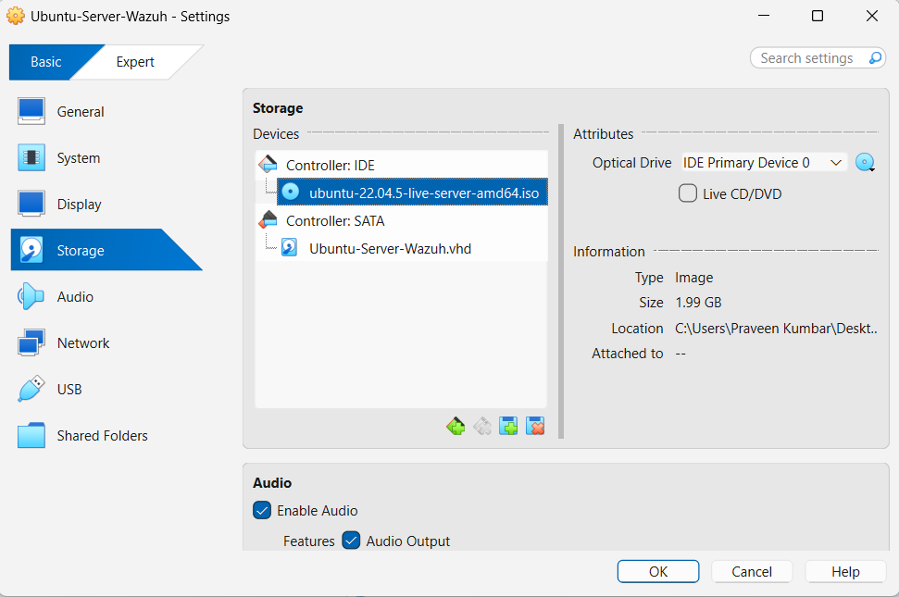
- Click Create.
- Choose VDI (VirtualBox Disk Image).
- Select Dynamically allocated.
- Set disk size to 30 GB.
- Click Create.

Step 5: Attach Ubuntu Server ISO
- Select the created VM → Click Settings.
- Go to Storage.
- Under Controller IDE, select Empty.
- Click the disk icon → Choose a disk file.
- Select the downloaded Ubuntu Server ISO.
- Click OK.

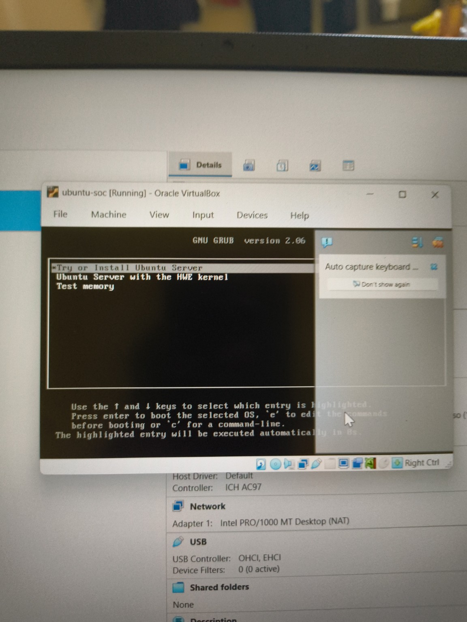

Ubuntu Server Installation Process

Start Installation
- Start the virtual machine.
- Select Install Ubuntu Server and press Enter.
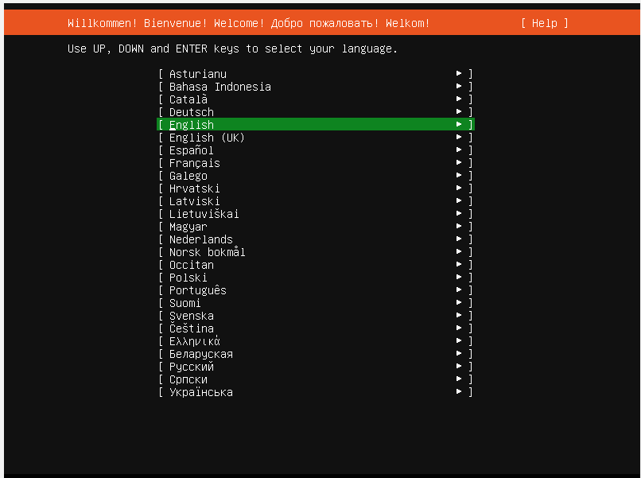

Step 7: Initial Configuration
- Language: English

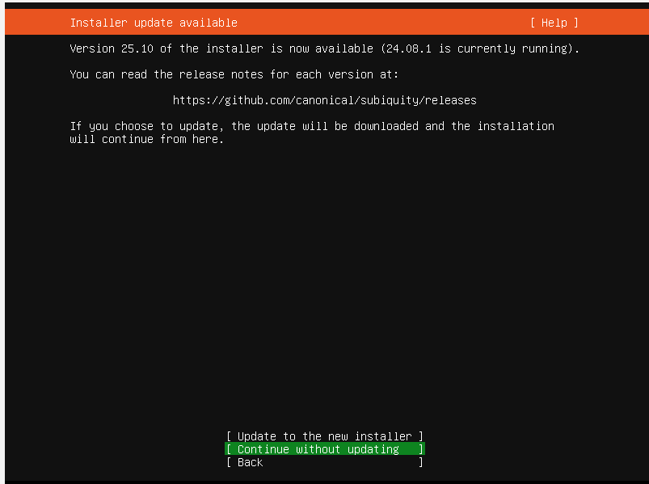

- Installer Guide: Continue without updating

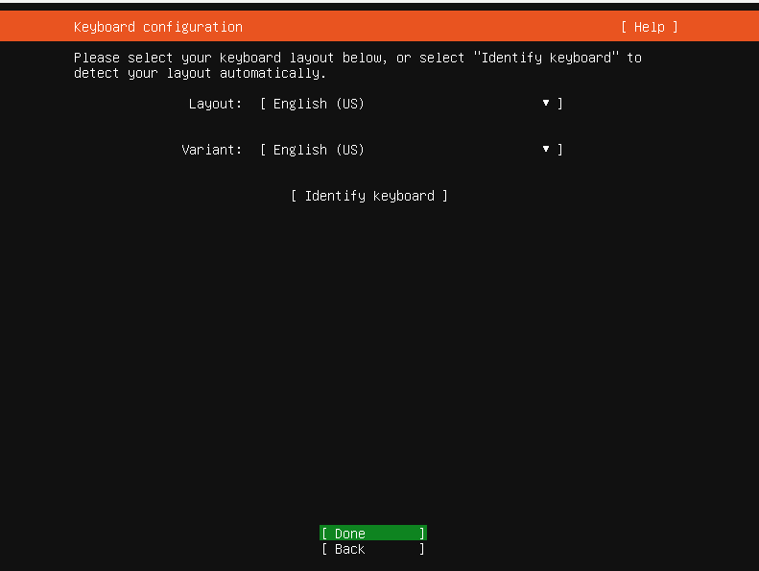

- Keyboard Layout: Default → Done

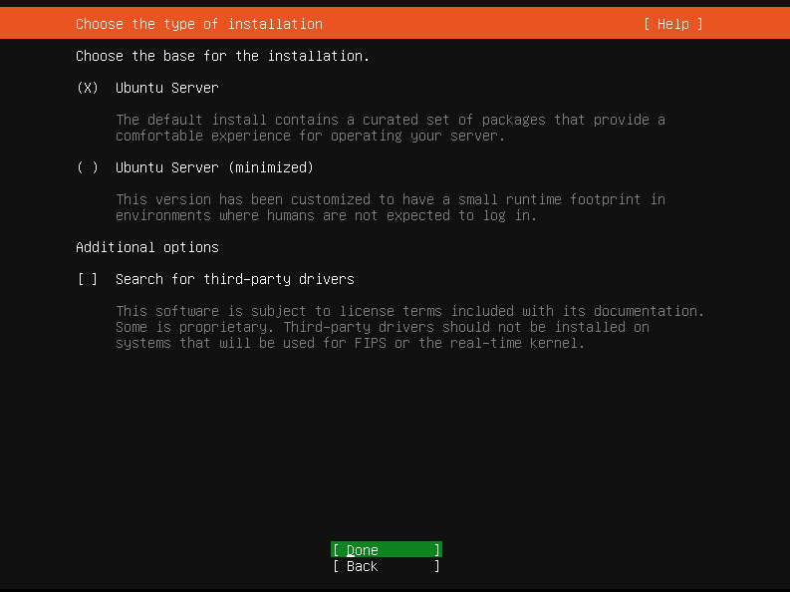

- Type of Installation: Ubuntu server

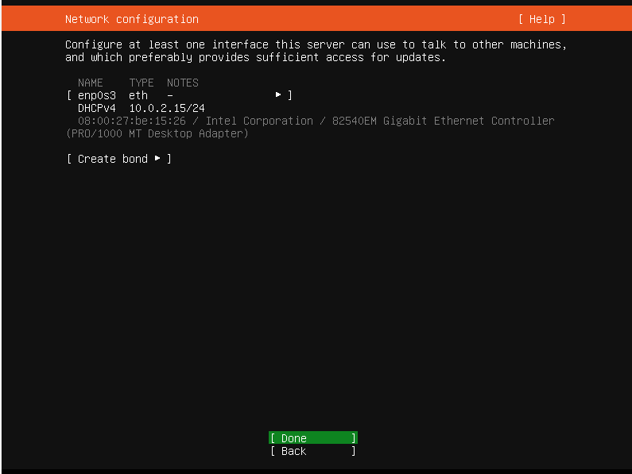

- Network Configuration: DHCP (Automatic) → Done

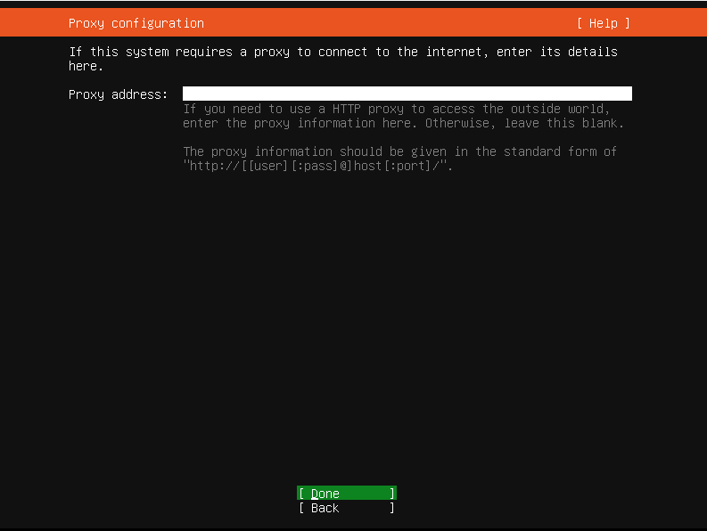

- Proxy Configuration: Leave empty → Done

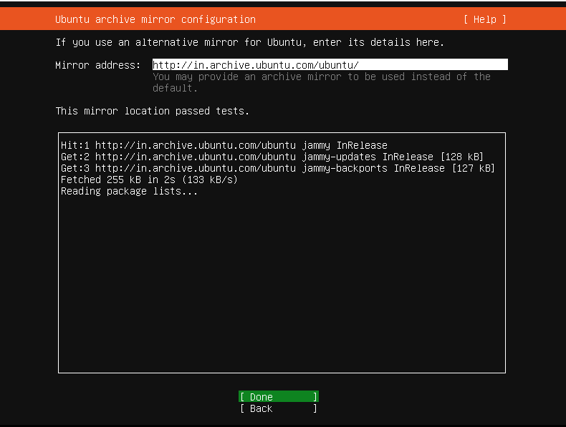

- Archive Mirror: Default → Done

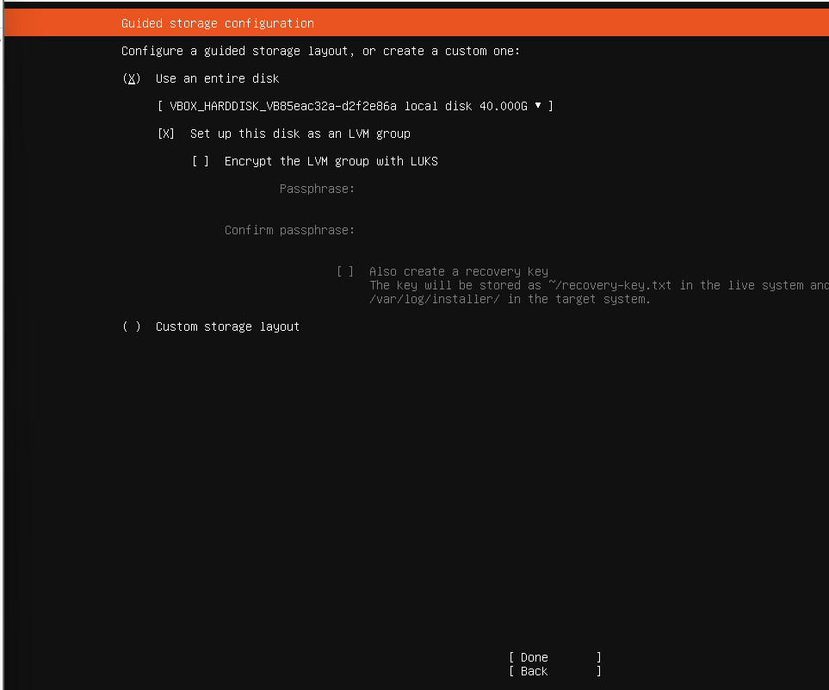

Step 8: Guided Storage Configuration
- Select Use an entire disk.
- Choose Set up this disk as an LVM group.
- Accept default storage layout.
- Click Done

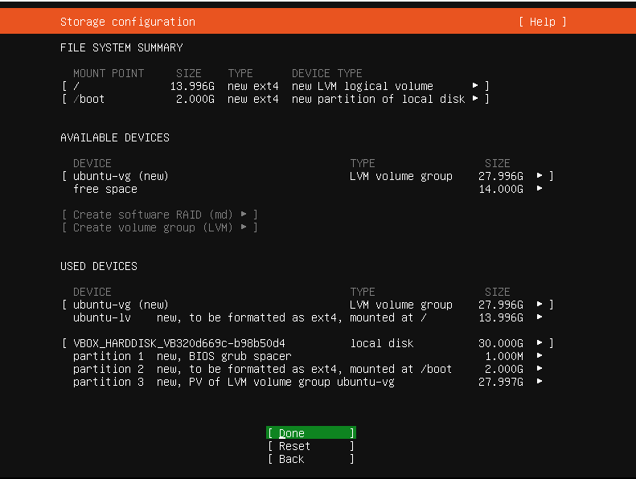

Storage Configuration

Click: done

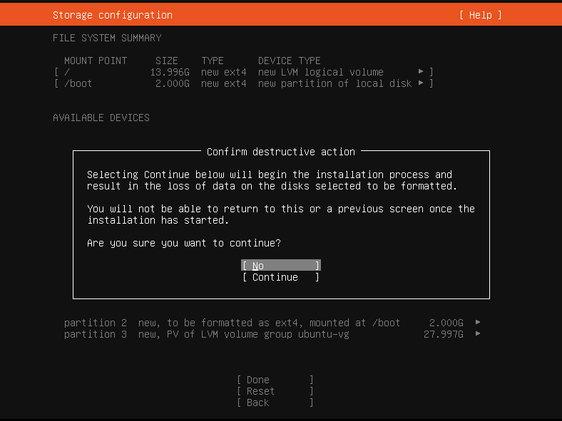

Confirm destructive action

Select continue and clink enter

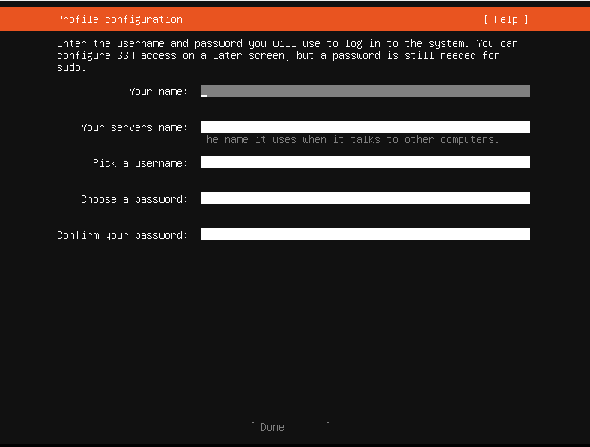
Step 9: User and System Setup
- Enter system details:
- Your name
- Server name
- Username
- Password
- Confirm password.
- Select Done.
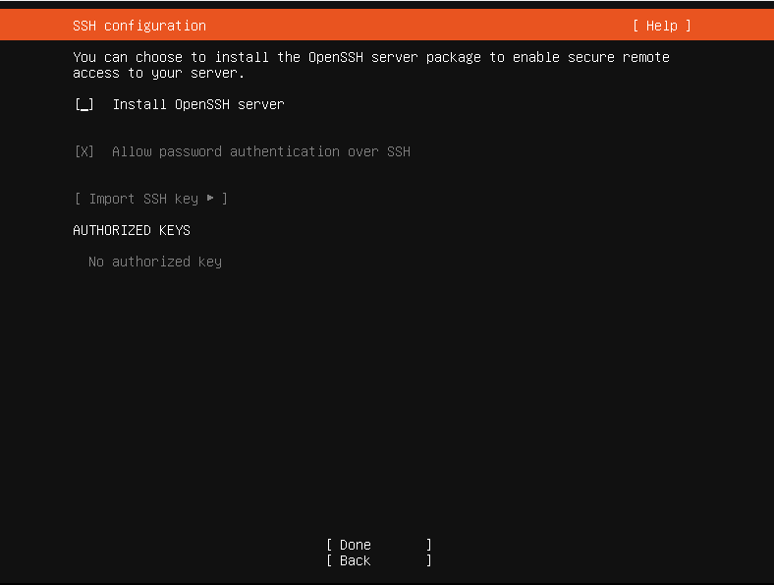

Step 10: SSH Configuration
- Select Install OpenSSH Server.
- Do not import SSH keys.
- Click Done.

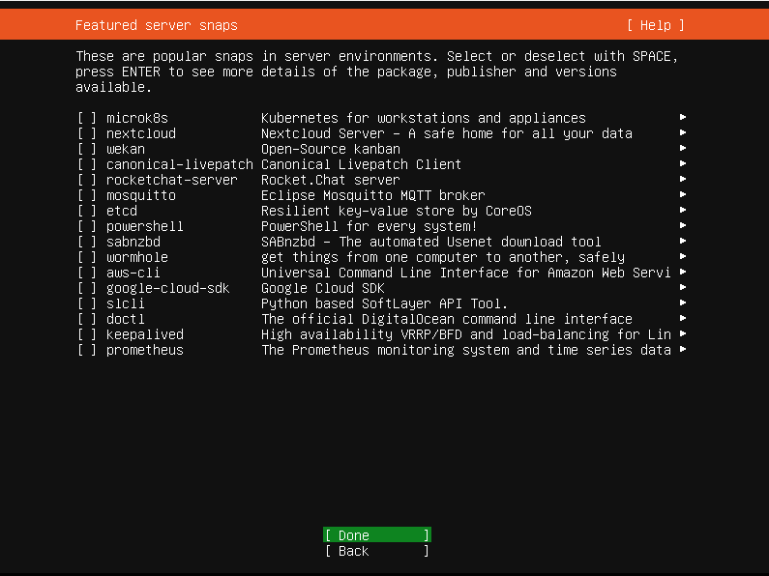

Step 11: Featured Server Snaps
- Do not select any additional snaps.
- Click Done.

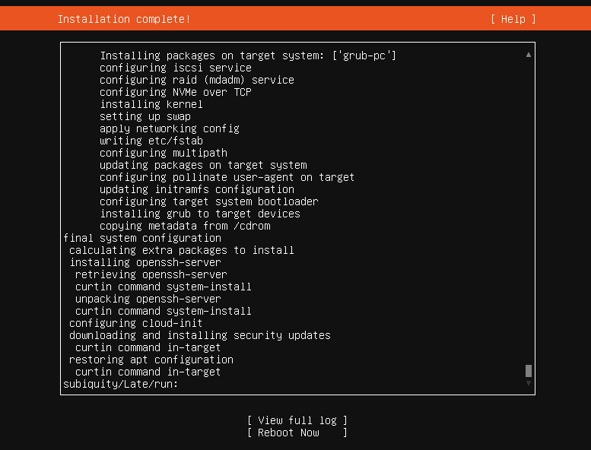

Step 12: Complete Installation
- Wait for the installation to complete.
- Once finished, select Reboot Now.
- Remove the ISO if prompted.
- Log in using the created username and password.

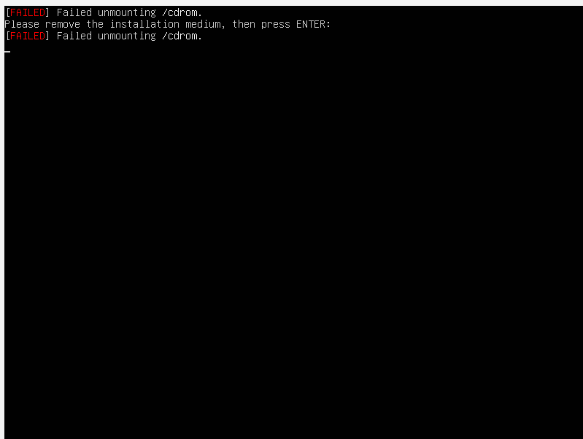

- [ERROR] Failed unmounting/cdrom
- Close the ubuntu server
- Start again

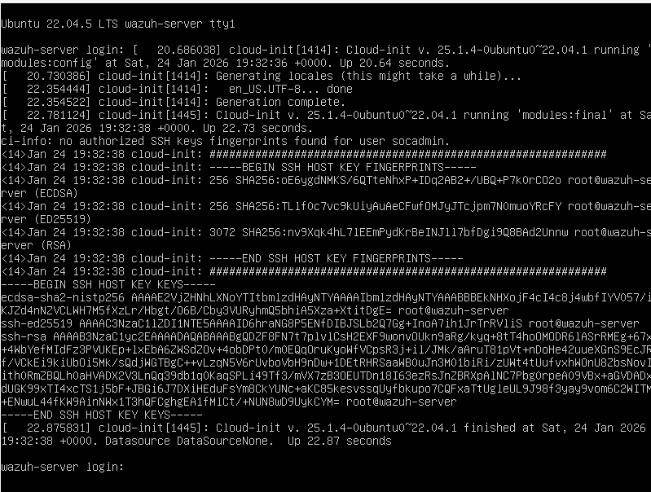
- After starting again
- Login using username and password created during profile configuration
- CMD will return
- Run this “sudo apt update”
- Run this “Sudo apt upgrade -y”

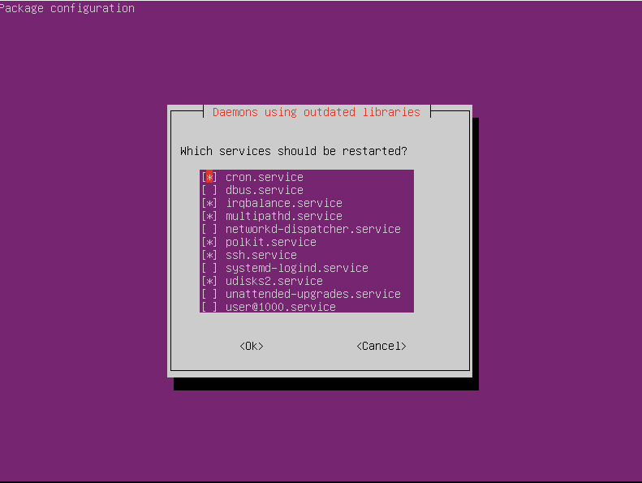

- Package configuration
- Use tab button to select ok and click ok

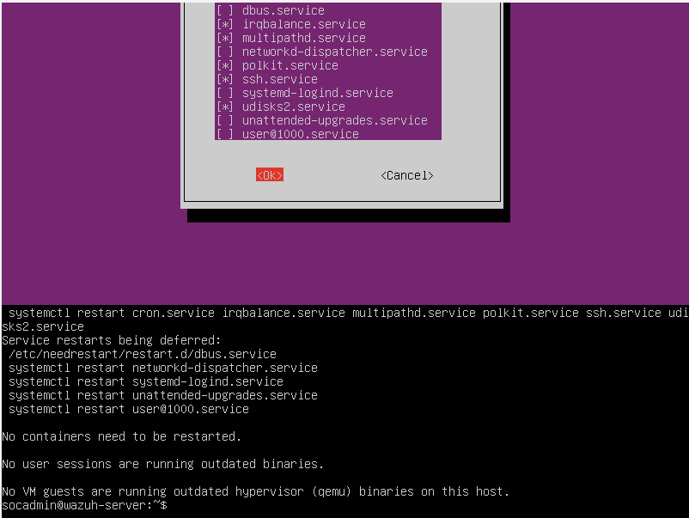

- Command will return

